eConstruction Change Order Review Quick Start Guide
- Starting the Review Process

Select a Reviewer

Create CO in Site Manager

- Accessing Your Task – Follow the Links in the Email Notification to the Task or your Task List.
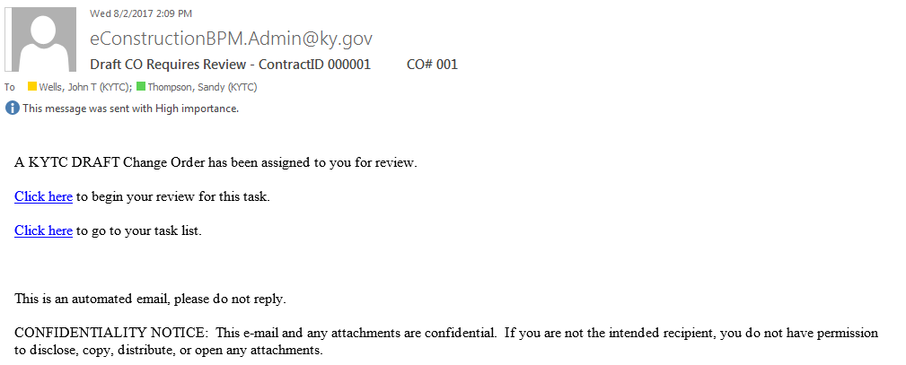

- Accessing Your Task – Logging In
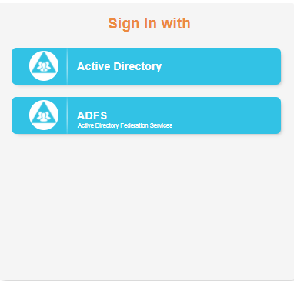
When using iPhone or iPad in ‘Private Browsing’ mode, you may receive a message indicating that your version of Safari is not supported. You can continue by clicking on ‘Continue Unsupported’ or by using normal browsing mode on your device.
Unsupported Safari Message
You may be prompted to Log In to the eConstruction BPM.
You will be prompted for your KYTC User Credentials if you select Active Directory.
Selecting ADFS will take you directly to your task or task list based on the link selected.

- Accessing Your Task – The Task List
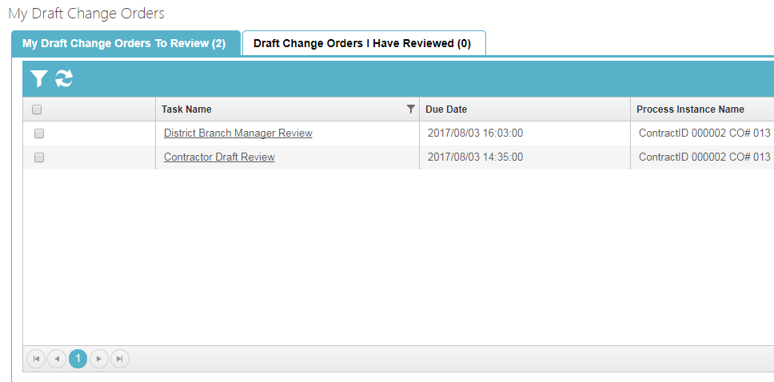

Select and open your task

- Reviewing the Change Order
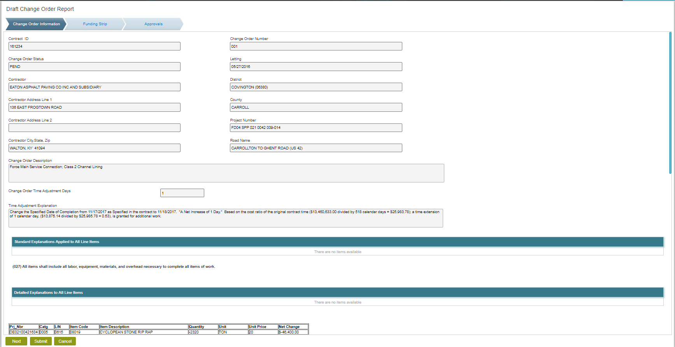
Scroll Bar navigates up and down

Navigate to Change Order pages

- Change Order Creator Review – Submit Your Decision
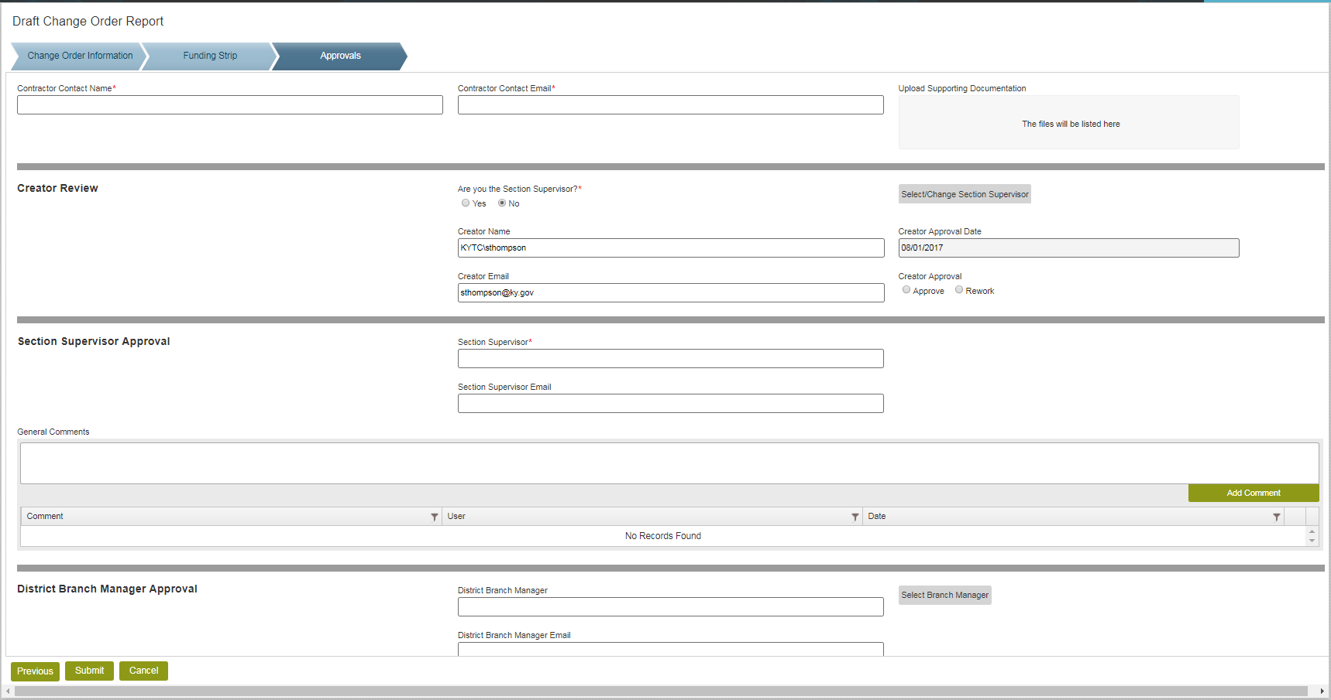
- Navigate to the Approval Section
- Enter Contractor Contact Name and Email (Mandatory)
- Upload Supporting Documentation (Optional)
  - File Size Limit 25 MB. Larger Files should be uploaded to Project Wise
- If you are the Section Supervisor, select Yes
  - Select your decision (as the Section Supervisor)
    - Approve – moves the Change Order to the next line reviewer
    - Rework – indicates that additional updates must be made in Site Manager.
- If you are not the Section Supervisor, verify that the populated Section Supervisor is correct.
  - Select your decision (as the Change Order Creator
    - Approve – moves the Change Order to the next line reviewer
    - Rework – indicates that additional updates must be made in Site Manager. If Rework is selected as your decision, you must enter comments in the General Comments box and select ‘Add Comment’.
  - If not correct, select a Section Supervisor using the select Button
- Verify that all pre-populated reviewers are correct.
  - If not correct: select using the select Button next to each reviewer
  - Note – you must use the select button, the Name and Email fields are read only.
- Select Submit

- Draft Review – Submit Your Decision
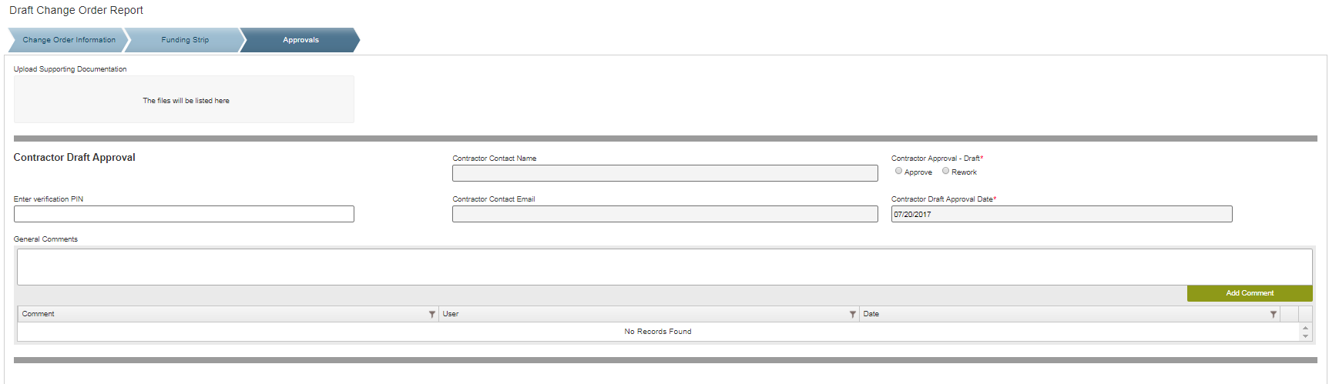
- Navigate to the Approval Section
- Select your decision
  - Approve – sends Change Order to the next line reviewer
  - Rework – sends email to Change Order Creator to make updates in Site Manager and ends the Draft review process until those updates are made. Comments are required if Rework is selected as the decision. Enter comments in the General Comments box and then select ‘Add Comment.
  - Review – should be selected as your decision if you see updates are highlighted that you feel should be re-reviewed by prior reviewers. Comments are required if Review is selected as the decision. Enter comments in the General Comments box and then select ‘Add Comment.
- Select Submit

- Pending Review – Submit Your Decision
- Navigate to the Approval Section
- Select your decision
  - Approve – sends Change Order to the next line reviewer
  - Rework – sends email to Change Order Creator to make updates in Site Manager and ends the Draft review process until those updates are made. Comments are required if Rework is selected as the decision. Enter comments in the General Comments box and then select ‘Add Comment.
- Select Submit

- CO Manager Final Approval
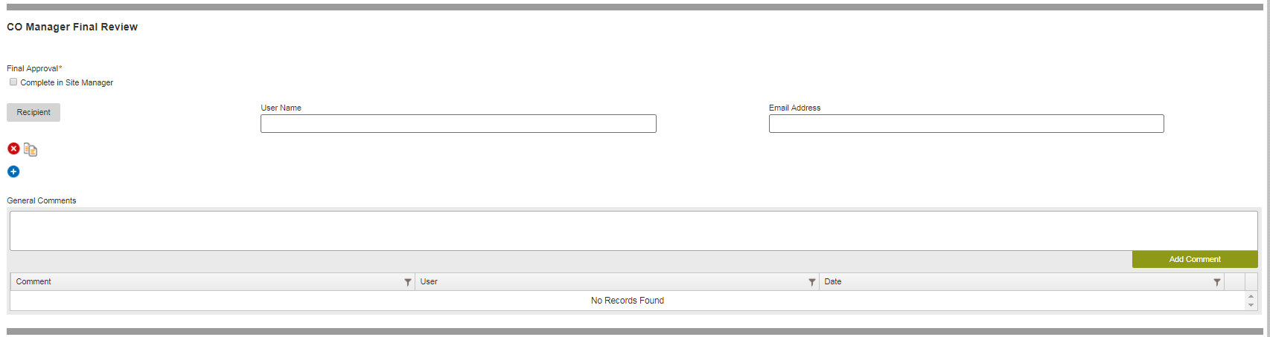
Select Notification Recipients

Indicate Final Approval Complete

- The final approval of the Change Order is made by the CO Manager in Site Manager.
- The CO Manager is assigned a task when the Change Order is ready for this approval.
- This task will not be assigned until the Fund Manager indicates that Funds are available.
- The CO Manager selects one or more individuals who are to be notified via email when the CO is approved

